Experiment: 10 5G Network Slicing Environment Using MATLAB
Objective 1:
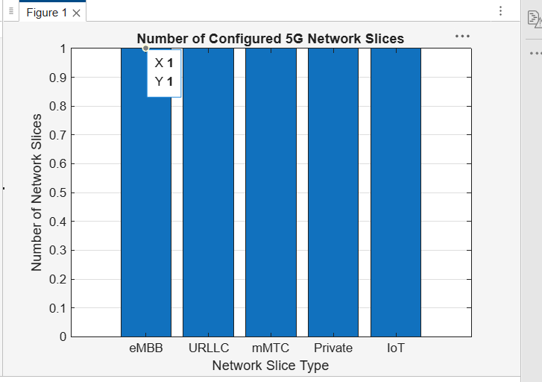

Objective 2:
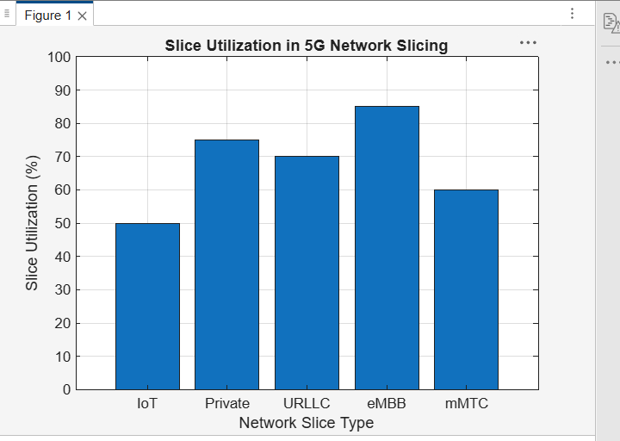

Objective 3:
